Home Page
Header Image
1
2
3
4
5
Why Garvik India
Building Brands from Scratch
Whether it is a first-time entrepreneur launching a new FMCG product, a tech founder looking to attract investors, or a boutique fashion label wanting to become a household name — Garvik India’s step-by-step approach has helped hundreds of ventures find their voice.
Many first-gen entrepreneurs arrive at Garvik India with nothing more than a concept or a dream. What they leave with is a complete brand identity, a compelling launch strategy, and the support system to turn that vision into a business engine.
From helping develop the company’s name and logo, choosing colours and fonts that reflect the ethos, crafting taglines that resonate emotionally, and conceptualising launch campaigns that spark conversations — Garvik India becomes part of the launch team of every entrepreneur it supports. The result? Businesses don’t just start — they make an impact.
True Partnership, Not Transactional Work
What differentiates Garvik India in a competitive marketplace is its relationship-driven approach. Here, clients are not treated as “projects” but seen as part of an expanding family of dreamers.
The team often meets founders personally, understands their struggles and motivations, brainstorms solutions, guides them on what to avoid—sometimes even advising less expensive options if it benefits the client’s long-term sustainability.
That kind of honesty, empathy and mentorship has made Garvik India not only a successful business — but also a trusted incubator of entrepreneurial confidence.

A 360 Integrated Digital Marketing & Advertising Company
What We Do
Services Name and Images ( Format Which you have shared with me) only more colour you can use as sample shared as our logo theme
About us Small
Our Latest Work
PR Event, Brand Promotion, Udaan, Ad Films, Product Road Show, Digital Marketing, Business Conference
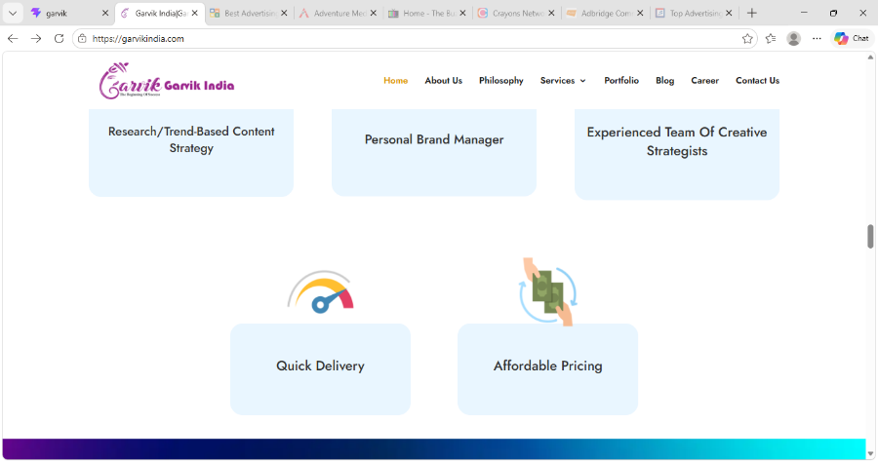

FAQ
From garvik India old site

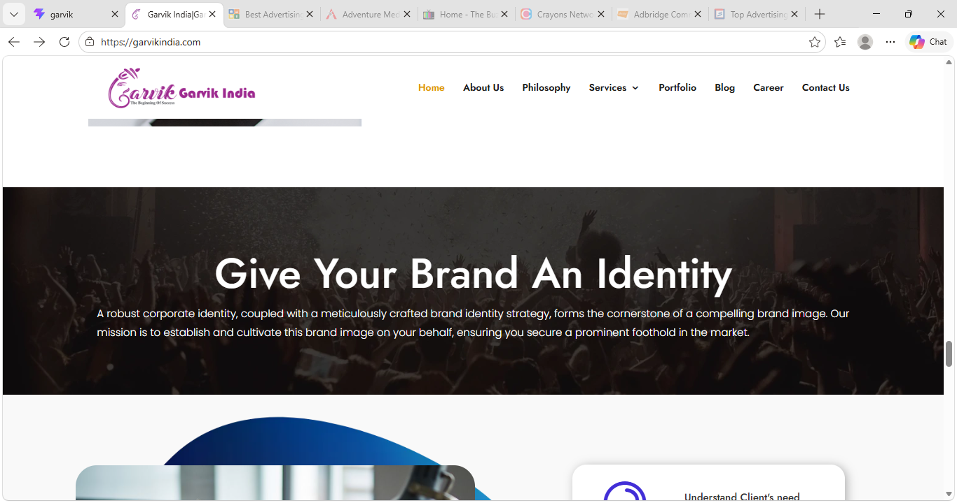

Something like this
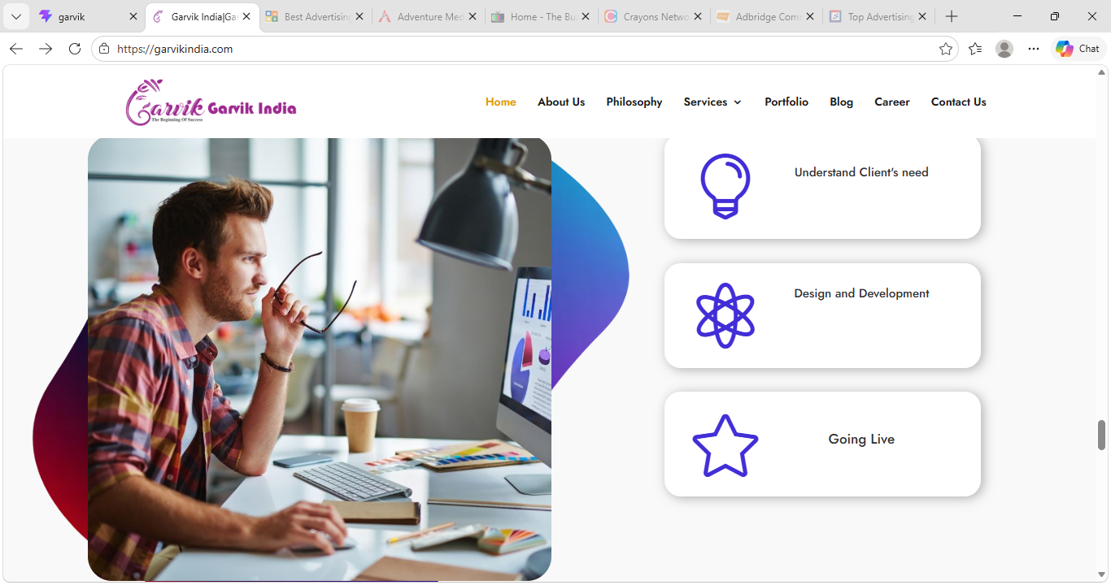
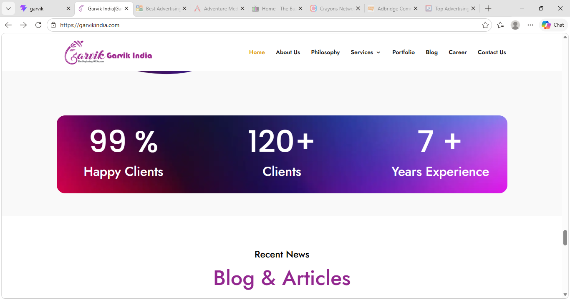
Then Blogs & Articles
Expert Consultation
Leave a Message
Enquiry Form
About us Page -2
Lighting the Torch for Tomorrow’s Entrepreneurs: The Garvik India Story
In a world where dreams are often fragile and the path to success is anything but linear, entrepreneurship stands as a beacon of courage. It is a fire that burns inside visionaries — those who choose to create their own future rather than wait for it to arrive. Fueling that fire requires more than just ambition. It demands guidance, visibility, resources, networks, and—most importantly—the power of a voice that amplifies one’s presence in the marketplace.
Since 2017, Garvik India has been that power. Emerging as one of India’s most dynamic 360° integrated digital marketing and advertising companies, Garvik India has positioned itself not simply as a service provider but as a true partner in the entrepreneurial journey. With its headquarters in India and a growing footprint across major regions, the company has been silently scripting success stories behind some of the most promising start-ups, SMEs, and emerging brands across industries.
But to understand how Garvik India empowers entrepreneurs today, we must first take a few steps back — to understand how it all began.
⸻
The Birth of an Idea (2017)
2017 was a landmark year for the Indian economy. Start-up India was on a rise, the focus on “Make in India” was growing, and a new wave of young founders was ready to disrupt everything from agriculture and healthcare to retail and technology. Yet, most entrepreneurs faced a common struggle — how to take an idea and present it to the market powerfully.
While India was filled with creative freelancers and marketing agencies, most early-stage entrepreneurs found themselves priced out of quality branding, left confused by complicated jargon, and stuck between design studios, digital consultants, and PR agencies who rarely communicated with each other.
Into that gap stepped Garvik India — a company that did not want to be another vendor, but rather a “complete growth partner” — streamlining the complex world of marketing and communications into one power-packed solution. Its purpose?
To give every entrepreneur and business a launchpad built on strategy, creativity, technology, and affordability.
⸻
One Company — Infinite Possibilities
Over time, Garvik India carved out a stunningly holistic model that redefined how entrepreneurs approached marketing. Instead of scattering their budgets across multiple agencies, they discovered that Garvik India’s unique structure covered all key pillars necessary for business growth under a single umbrella:
Core Support Area
How It Helps Entrepreneurs
Brand Strategy & Identity
Logo Design, Tagline, Positioning, Brand Voice, Vision Shaping
Creative & Advertising
TVCs, Digital Ads, Print, Outdoor Campaigns, Radio Spots, Packaging, Brochures
Digital & Performance Marketing
Social Media, SEO, PPC, E-mails, WhatsApp Marketing, Influencer Integration
PR & Reputation Building
Media Coverage, Launch Events, Celebrity Jury Meets, Editorial Features
BTL & On-ground Activation
Roadshows, Product Launches, Exhibitions, Sampling Activities
Networking & Ecosystem Building
Business Conclaves, Panel Discussions, Felicitation Events, Start-up Showcases
Each of these legs is powered by highly specialized teams — strategists, brand consultants, designers, content creators, PR managers, digital marketers, and event experts — all working together towards one purpose: entrepreneurial success.
⸻
The Ripple Effect of Impact (2017–2024)
In just a few years since inception, Garvik India’s influence has touched entrepreneurs from sectors as diverse as:
• Retail & FMCG
• Healthcare & Wellness
• Real Estate & Architecture
• Education & EdTech
• Manufacturing & Technology
• Hospitality & Lifestyle
• Agriculture & Environment
• Fashion, Art & Culture
Several of these entrepreneurs credit Garvik India for helping them land their first 1,000 customers, get featured in the media, win awards, attract investors, or scale into new markets.
The numbers are impressive — but the real magic lies in the stories:
The baker who opened her first café chain, the rural innovator who caught national attention, the local brand now exporting internationally — each began with a vision, and found a champion in Garvik India.
⸻
The Road Ahead
As India steps confidently into a future driven by innovation, Garvik India remains committed to supporting the dreams of entrepreneurs — not as a vendor, but as a growth companion. The company is currently expanding its footprints, strengthening its digital backbone, and creating more platforms where entrepreneurs can learn, connect, and flourish.
Because Garvik India believes that when entrepreneurs rise, the nation rises.

From the Founder’s Desk – Kamal Saini
“When we started Garvik India in 2017, our dream was simple — to build a place where every entrepreneur, no matter how big or small, felt heard, supported, and empowered.
Over the years, we’ve seen countless founders walk in with ideas and walk out with brands. That is the power of belief — and the magic that happens when creativity, strategy, and commitment come together with purpose.

At Garvik India, we don’t merely create logos, campaigns, or digital posts. We create confidence. We help you stand tall in the marketplace. Whether you’re just beginning or scaling your dream, my message to every entrepreneur is this — never underestimate your journey. You may be small today, but your vision is already big enough to change the world.
We are honoured to be a partner in your growth story — not just to advertise your brand, but to celebrate your entrepreneurial spirit. Your success is the true headline we wish to create.”
– Kamal Saini
Founder & Growth Partner, Garvik India

Page -3 Philosophy
At Garvik India, our philosophy is rooted in a profound belief in the transformative power of creativity, innovation, and strategic excellence. We offer a comprehensive suite of services that encompass Ad Films, Integrated Brand Management, Print Media, TV & Radio Ads, PR/Felicitation Events, Creative Design & Content, Business Conferences, Product Road Shows/Demonstrations, and Digital Marketing. These services are not mere offerings; they are the tangible expressions of our commitment to your brand’s success and your vision’s realization.
We understand that a brand is more than just a logo; it’s an ecosystem of perceptions and experiences. Our Integrated Brand Management approach ensures that every facet of your brand is meticulously crafted to resonate with your audience. Through strategic thinking, creative brilliance, and data-driven insights, we create brand narratives that stand out in the market.
Creative design and content are the visual and narrative storytellers of your brand. We craft compelling narratives and captivating visuals that resonate with your audience. Our designs are not just aesthetically pleasing; they are strategically aligned with your brand’s objectives.
Our Vision
Our vision is to empower brands to stand out in a crowded marketplace, forging deep connections with their audience. We strive to be the architects of brand identity, ensuring that every touchpoint communicates a cohesive, compelling message. With strategic insight and creative brilliance, we see brands becoming not just market leaders but also vehicles of positive change. Garvik India is driven by a commitment to excellence, innovation, and a relentless focus on our clients’ success.
Together, we aim to empower brands and organizations to rise above challenges, leaving an enduring legacy of success and impact on the world stage.
Our Mission
Our mission is to craft brands that not only excel in the marketplace but also resonate deeply with their audience. We aim to be the architects of brand identities, forging a path to enduring success.
Through strategic insights and creative brilliance, we empower brands to become beacons of innovation and purpose. Garvik India is driven by a relentless commitment to excellence, innovation, and client-centricity.
We strive to be leaders in the industry, continuously adapting to emerging trends, harnessing cutting-edge technology, and nurturing a team of passionate professionals who share our mission.

Print Media
In the digital age, where the virtual realm often takes center stage, the significance of print media should not be underestimated. It remains a powerful and tangible medium for conveying information, promoting brands, and leaving a lasting impact on your target audience. Amid this dynamic landscape, Garvik India emerges as your go-to partner for the finest print media services.
Unparalleled Expertise
With a legacy of excellence spanning many years, Garvik India has honed its expertise in print media services to perfection. Our dedicated team of professionals possesses an in-depth understanding of the nuances of print, from design intricacies to material selection and production processes.
Cutting-Edge Technology
At Garvik India, we believe that staying ahead in the print media industry requires constant innovation and investment in state-of-the-art technology. We have spared no effort in equipping our facilities with the latest printing presses, finishing equipment, and quality control mechanisms. This commitment to technological advancement enables us to deliver print media solutions that are not just good but exceptional.
Customization Beyond Compare
We understand that every client is unique, and their print media needs reflect their individuality. Garvik India takes pride in offering unparalleled customization options. .
Whether you require business cards that make a memorable first impression, brochures that tell your brand story, or posters that demand attention, we have the expertise to craft tailored solutions that align perfectly with your vision and objectives
Quality Assurance
Quality is the cornerstone of our print media services. Garvik India adheres to stringent quality control processes at every stage of production. From selecting the finest materials to conducting rigorous checks for color accuracy and finishing quality, we leave no room for compromise. When you choose us, you can be confident that your print materials will exude excellence.
Eco-Friendly Practices
In an era where environmental responsibility is paramount, Garvik India is committed to sustainable print media practices. We employ eco-friendly inks, responsibly sourced paper, and recycling initiatives to minimize our ecological footprint. By choosing us, you contribute to a greener and more sustainable future.
Timely Delivery
We understand that timeliness is often a critical factor in your print media projects. At Garvik India, we prioritize meeting deadlines without compromising on quality. Our streamlined processes and efficient workflows ensure that your materials are delivered when you need them.
In a world of constant digital noise, print media stands out as a tangible and impactful means of communication. Garvik India’s dedication to excellence, innovation, customization, quality assurance, eco-friendliness, and on-time delivery make us the top choice for all your print media needs. Whether you are looking to make a bold statement, showcase your brand, or convey important information, trust Garvik India to transform your vision into stunning print reality. Experience the difference of working with the best in the business. Choose Garvik India for unparalleled print media services that leave a lasting impression.
FAQ

Ads Films
Ad films serve as a powerful tool to validate marketers’ claims by evoking the right emotions and desired consumer behaviors. However, only a select few ad films truly achieve this, with most fading into obscurity prematurely. At Garvik India, we ensure none of our ad films meet such a fate.
We’ve witnessed the evolving landscape of advertising, which is now more complex than in previous decades. Adapting to fragmented mediums, distracted consumers, and shifting marketing objectives, we tailor our approach accordingly.
When crafting ad films, we begin by donning our marketer’s hat. In-depth product research and direct engagement with end-users yield valuable category insights.
However, not all insights are transformative; it takes meticulous analysis to identify the one compelling idea worth backing.
Once the big idea is established, our creative team explores multiple renditions to achieve the same objective.
We are focusing on the most effective and impactful approach.
Garvik India ad films establish an immediate connection with the audience, ensuring they remember them long after they’ve aired. At Pictures Unfold, we prioritize the product as the hero, ensuring the creative never overshadows it.
Our success lies in associating the product seamlessly with the creative. We maintain open communication with brand custodians, incorporating their input at every stage of production. Our films are deeply rooted in product narratives and brand insights, earning appreciation from all stakeholders.
PR / Felicitation Event\
PR (Public Relations) and felicitation events are essential components of a comprehensive communication strategy for businesses, organizations, and individuals. These events serve multiple purposes, from recognizing achievements to enhancing reputation and building positive relationships with stakeholders.
One of the primary objectives of PR/felicitation events is to celebrate and acknowledge accomplishments.
Whether it’s honoring employees for their hard work, recognizing outstanding achievements within an industry, or celebrating milestones such as anniversaries or product launches, these events provide a platform to applaud success.
By publicly acknowledging and appreciating accomplishments, organizations and individuals demonstrate their commitment to excellence.
Strengthening Relationships:
PR/felicitation events offer a valuable opportunity to strengthen relationships with key stakeholders. Whether it’s customers, partners, investors, or employees, these gatherings create a sense of belonging and appreciation. They foster positive interactions, which can lead to enhanced loyalty, trust, and collaboration. Building and nurturing these relationships is crucial for long-term success.
Enhancing Reputation:
A well-executed PR/felicitation event can significantly contribute to enhancing an entity’s reputation. When an organization or individual is recognized for their contributions, it reinforces their credibility and authority in their respective fields. Positive media coverage and word-of-mouth generated from these events can further bolster reputation.

Promoting Brand Visibility:
For businesses, PR/Felicitation events are an effective way to promote brand visibility. By hosting or participating in such gatherings, organizations can showcase their products, services, and values to a broader audience. This increased visibility can translate into brand recognition and market growth.
PR/Felicitation events are memorable experiences that leave a lasting impression on attendees. These events often involve carefully planned presentations, speeches, and entertainment, all designed to evoke positive emotions. When people associate an organization or individual with a memorable and enjoyable event, it leaves a favorable imprint on their minds.
PR/Felicitation events are powerful tools for celebrating success, building relationships, enhancing reputation, and communicating effectively. They serve as essential components of a well-rounded PR and communication strategy, contributing to long-term success and growth for businesses, organizations, and individuals. Whether it’s honoring milestones or recognizing outstanding contributions, these events play a vital role in shaping perceptions and fostering positive connections within the community and industry.

Business Conferences
Business conferences are dynamic gatherings that play a pivotal role in the modern corporate landscape. These events bring together industry experts, professionals, entrepreneurs, and thought leaders from diverse sectors to exchange knowledge, share insights, and chart the course for future success.
Whether large-scale international affairs or intimate niche gatherings, business conferences are catalysts for innovation, networking, and professional development.
At the heart of every business conference is the pursuit of knowledge and learning. Conferences provide a unique platform for attendees to delve into industry trends, emerging technologies, and best practices. Entrepreneurs and startups often use these platforms to showcase their innovations, seeking investors, partners, and early adopters.
Through keynote speeches, panel discussions, workshops, and interactive sessions, participants gain valuable insights that can shape their strategies and decision-making processes.
Business conferences are treasure troves of networking opportunities. They facilitate connections between like-minded individuals, potential collaborators, clients, and mentors.
Networking at conferences can lead to new business partnerships, career advancements, and even the genesis of groundbreaking ideas. These events serve as hubs for relationship-building and expanding one’s professional circle.
Innovation is the lifeblood of business, and conferences serve as marketplaces for new ideas, products, and services.

Product Road Show
In the world of business and technology, showcasing a product through a road show or demonstration is a pivotal strategy that not only introduces innovation but also forms a direct connection with the audience. These events serve as a platform for companies to exhibit their latest offerings, providing an immersive experience that goes beyond the realm of traditional marketing.
In this note, we delve into the significance and key components of a product road show or demonstration, highlighting its role in driving success and fostering lasting relationships. Whether it’s a cutting-edge tech gadget, a groundbreaking software application, or a revolutionary consumer product. The road show or demonstration serves as the grand reveal that captivates the audience and leaves them in awe of what is possible.
One of the most significant advantages of a product road show or demonstration is the opportunity for direct engagement with potential customers, partners, and stakeholders. Unlike traditional advertising methods, these events allow companies to interact with their audience in real-time. Attendees can ask questions, provide feedback, and gain a deeper understanding of the product’s features and benefits.Each product road show or demonstration is meticulously planned to offer a personalized and immersive experience.
From interactive demos and hands-on experiences to informative presentations and one-on-one consultations, attendees are guided through the product’s journey, enabling them to connect with it on a personal level.

Digital Marketing
Powering the Digital Age Entrepreneur
Post-2020, the rise of digital conversations, e-commerce, and content-driven engagement created an even bigger challenge for entrepreneurs — how to stand out in the chaos of the internet?
Garvik India raced ahead by building a full-stack Digital Marketing Command Centre that handles:
• Creative social media feeds
• Targeted ad campaigns
• ROI-based lead generation systems
• Influencer collaborations
• Performance analytics
• Community engagement
Every entrepreneur working with Garvik India gets a customised growth plan that suits their industry, budget and business stage. Some are looking for visibility… others want conversions… many want both. Garvik India listens first, builds later.
The result?
Entrepreneurs no longer feel “lost in the digital crowd”. They feel seen, heard and—most importantly—supported.
If one method falls short, adjustments can be made swiftly or alternative approaches can be explored to identify what resonates and what doesn’t. It’s essential to recognize that digital marketing encompasses diverse methods and approaches, each with its unique attributes and advantages.

Some prime examples of online digital marketing strategies include:
Search Engine Optimization (SEO): Optimizing your website to enhance its visibility and ranking on search engines like Google.
Pay-Per-Click Advertising (PPC): Investing in advertisements that appear on search engine results pages or across social media platforms.
Social Media Marketing: Crafting and sharing engaging content on platforms such as Facebook, Twitter, and Instagram to boost brand awareness and audience engagement.
Content Marketing: Creating and sharing valuable content such as blog posts, e-books, or videos to attract and retain a specific audience.
Leveraging Traditional Offline Media: Utilizing traditional marketing channels like radio, TV, billboards, print, and in-person events for advertising.
Success in this domain necessitates ingenious thinking to effectively engage both prospective and current customers, delivering a compelling message that guides a strategy tailored to meet their needs.
Creative Design & Content
Creative design and content are the twin engines that drive engagement, captivate audiences, and leave a lasting imprint on the mind.
Whether it’s a brand’s visual identity, a marketing campaign, or a user interface, the fusion of creative design and compelling content is a transformative force that brings ideas to life. Let’s delve into the profound impact of creative design and content in the modern world.
Creative design is the art of visual storytelling. It transcends language barriers, communicating ideas, emotions, and messages through images, color schemes, typography, and layout.Whether it’s a logo that represents a brand’s ethos or an infographic that simplifies complex data.
Compelling content is the bridge that connects brands with their audiences. It encompasses not only words but also videos, animations, and interactive elements. Effective content educates, entertains, and engages. It solves problems, answers questions, and provides value. From blog posts to social media updates, content is the voice of a brand, resonating with its target demographic.
Creative design plays a pivotal role in crafting a brand’s identity. Logos, color schemes, and visual elements are the building blocks of recognition.
A well-designed brand identity creates a memorable image in the minds of consumers. It differentiates a brand in a crowded marketplace and fosters loyalty.Content is at the heart of marketing and advertising. From catchy slogans to persuasive product descriptions, from visually stunning ads to emotionally resonant videos, content grabs attention and influences purchasing decisions.

It tells the brand’s story and creates a connection with consumers.Creative design and content inspire innovation. They challenge conventions, push boundaries, and spark new ideas. Creative campaigns and content that break the mold often become viral sensations, setting trends and influencing industries.
In conclusion, creative design and content are the architects of the modern digital landscape. Together, they shape narratives, forge connections, and drive success in an increasingly competitive world. From branding to user experience, education to marketing, the impact of creative design and content is undeniable. They are the instruments through which ideas are transformed into experiences, and stories are told to captivated audiences. In a world where creativity and communication reign supreme, creative design and content are the keys to unlocking the full potential of any endeavor.

Integrated Brand Management
Are you effectively conveying the intangible yet crucial aspects of your business to your potential customers? Do your unique qualities stand out to someone who encounters your advertisements, notices your signage, or visits your premises?
The process of branding often follows or incorporates positioning strategies, offering similar advantages such as achieving consensus and gaining a deeper understanding of the potential impact of robust branding on both short-term and long-term growth.
Branding combines visual elements and content while maintaining consistency in thought and purpose.
Moreover, your brand descriptor should also delineate your specific market niche and arouse curiosity among potential customers.
Brand identity is the image that a company establishes within the market and among its clientele. This identity encompasses features, attributes, benefits, performance, quality, service support, and the values inherent to the brand.Think of the brand as a personality, a set of values, and the place it holds in people’s minds.
In essence, brand identity encompasses all the qualities a company aims for its brand to represent. A strong corporate identity, when aligned with a strategically planned brand identity, creates the desired brand image. We specialize in crafting this brand image for you, allowing you to establish a firm foothold in the market.

FAQ
Frequently

Broadcasting Advertising
Broadcast advertising is a dynamic and influential medium through which companies and organizations convey their messages to a wide and diverse audience.
This form of advertising leverages radio and television to reach potential customers and promote products, services, or causes. In this note, we explore the significance of broadcast advertising and its enduring impact on the advertising landscape.
Broadcast advertising’s most prominent feature is its unparalleled ability to reach a mass audience. Whether through terrestrial radio, television, or streaming platforms, broadcast advertising allows businesses to tap into millions of households and individuals simultaneously.
Television advertising, in particular, offers the unique advantage of combining visual and auditory elements. This powerful combination enables advertisers to create compelling narratives, showcase products in action, and evoke emotions in viewers. Through captivating visuals, music, and storytelling, broadcast advertisements have the potential to leave a lasting impression on consumers.
Targeted Messaging
While broadcast advertising can reach a vast audience, it also offers options for targeted messaging. Advertisers can select specific time slots, channels, or programs that align with their target demographic.
This allows for more precision in reaching the right audience and maximizing the return on investment. Broadcast advertising plays a pivotal role in brand building. Consistent exposure on television or radio can help reinforce brand identity and create a sense of trust and familiarity with consumers. It allows brands to tell their story, highlight their values, and differentiate themselves from competitors.
Broadcast advertising has the advantage of real-time impact. Advertisers can run live commercials during major events, news broadcasts, or sports games, ensuring that their message reaches a captive audience at precisely the right moment. This immediacy can be especially effective for time-sensitive promotions or product launches.
Despite its many advantages, broadcast advertising does come with challenges, including high production costs, competition for airtime, and the need to stand out in a crowded landscape. Advertisers must carefully consider their messaging, creative execution, and media buying strategies to ensure a successful campaign.
In conclusion, broadcast advertising remains a potent and influential medium in the advertising world. Its mass reach, ability to convey visual and auditory messages, and capacity for targeted messaging make it a versatile tool for advertisers. As technology continues to shape the industry, broadcast advertising will continue to adapt, providing new and exciting ways for brands to connect with their audiences and make a lasting impact.

Celebrity Endorsement

Portfolio Page
In the dynamic world of business and marketing, effective brand management is the cornerstone of success. Garvik India stands as a premier provider of integrated brand management solutions, offering a comprehensive suite of services that encompass Broadcast Advertising, Print Media, Ad Films, PR/Felicitation Events, and Business Conferences.
With a relentless commitment to excellence and a passion for innovation, Garvik India is your strategic partner in elevating your brand to new heights. In today’s fast-paced media landscape, broadcast advertising remains a potent tool for reaching mass audiences. Garvik India specializes in crafting compelling and memorable television and radio advertisements that capture the essence of your brand. Our team of creative minds works diligently to develop visually stunning and emotionally resonant campaigns that not only inform but also engage and inspire. Whether it’s a 30-second TV spot or a catchy radio jingle, we harness the power of the airwaves to ensure your brand message leaves an indelible mark.

Contact Us
